Muscle Pain Got You Down? Discover the Power of Pain O Soma 350mg
Muscle pain isn’t just discomfort it can mess up your entire day, week, or even life. Whether it's from long working hours, an unexpected injury, or an underlying condition, muscle pain has a sneaky way of dragging your energy down. But what if there was something that could give you fast relief without making you feel like a zombie?
Let us introduce you to Pain O Soma 350mg (Carisoprodol), a game changer in muscle relaxation therapy. No fluff just real talk about how this powerful tablet can help you regain control, feel better, and get moving again.

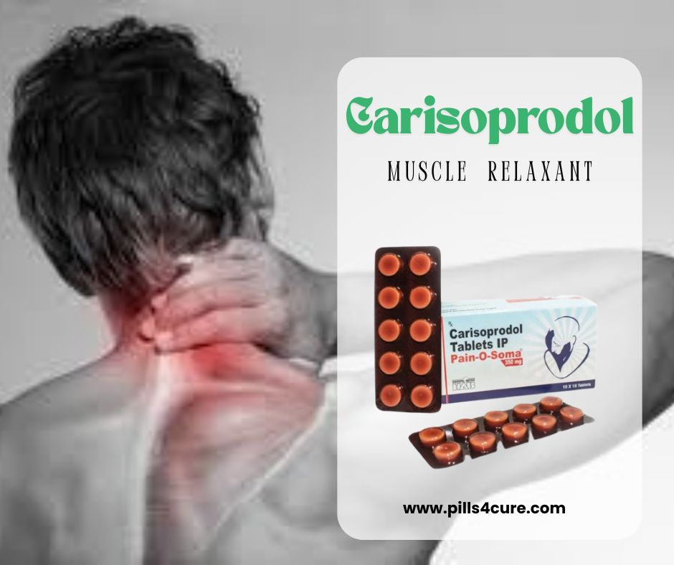

Why Does Muscle Pain Even Happen?
Before we dive into the solution, let’s get to the root of the problem.
Muscle pain, also known as myalgia, can come from a variety of sources:
- Overuse or strain from activities like gym workouts, lifting heavy objects, or even bad posture.
- Injuries such as sprains, tears, or pulls.
- Medical conditions like fibromyalgia, sciatica, or chronic fatigue syndrome.
- Tension and stress, which can tighten muscles and lead to pain over time.
When your muscles scream in protest, it’s often because of inflammation, nerve compression, or spasms. That’s where a smart muscle relaxant like Pain O Soma 350mg (Carisoprodol) can step in.

What is Pain O Soma 350mg?
Pain O Soma 350 mg (soma 350mg) is a muscle relaxer designed to target musculoskeletal discomfort and help you feel at ease. The active ingredient is Carisoprodol, which works by calming down the signals between your nerves and brain. In simpler words it gives your body and brain a much needed break from the pain cycle.
Pain O Soma doesn’t just mask the pain; it helps reduce muscle spasms and eases tension, so your body can actually start to recover.

How Does pain O soma 350mg Work?
Pain O Soma 350 mg (soma pill) doesn’t fight the pain head on like a painkiller does. Instead, it soothes the nervous system, easing muscle stiffness and contractions. When muscles are relaxed, your pain reduces naturally.
Think of it like this:
You’ve got a rope with a knot (your muscle cramp). Pain O Soma 350 mg gently untangles that knot by making the rope soft and flexible again.
It’s typically used for short-term treatment most commonly for acute muscular injuries. It gives the body a break long enough for healing to kick in.

Top Benefits of Pain O Soma 350mg
Here’s what makes it a favorite among many people dealing with muscle pain:
1. Fast Acting: Most users report feeling relief within 30 to 60 minutes after taking it. That’s much quicker than waiting around with a heating pad or massage oil.
2. Promotes Sleep and Relaxation: Because it calms your muscles, Pain O Soma also makes it easier to rest something crucial for recovery.
3. Works Well for Acute Pain: Injured your back while lifting groceries or pulled a muscle playing tennis? Pain O Soma 350mg is designed exactly for this kind of short-term situation.
4. Convenient Dosage: At 350mg, it’s a balanced dose not too high to knock you out, and not too low to be ineffective.

When to Use Pain O Soma 350mg?
This medication (soma medication) is usually prescribed for:
- Lower back spasms
- Neck stiffness
- Sports injuries
- Post-surgery muscle strain
- Chronic muscle fatigue disorders (under supervision)
Important note: Pain O Soma is not meant for long-term use. It’s best used for 2-3 weeks max under the guidance of a doctor.

How to take pain O soma 350mg safely
- Dosage: Usually one tablet (pain O soma 350 mg) 2 TO 3 times a day. Never self-medicate.
- With or Without Food: Can be taken with a glass of water, with or without meals.
- Avoid Alcohol: Mixing it with booze can increase drowsiness and dizziness.
- Stick to Timing: Consistency is key. Don’t skip or double dose.
Always follow your doctor’s instructions. This isn’t candy it’s a powerful medicine.

Side Effects of pain O soma 350mg?
As with any medication, Pain O Soma 350mg comes with some potential side effects. The good news? Most are mild and temporary.
Common ones include:
- Drowsiness
- Dizziness
- Headache
- Dry mouth
- Mild nausea
Rare side effects may involve allergic reactions, chest pain, or breathing difficulties. If you experience anything severe, stop the medication and contact a healthcare provider right away.

Who Should Avoid Pain O Soma 350mg?
You should not take Pain O Soma 350 mg if you:
- Are allergic to Carisoprodol.
- Have a history of substance abuse.
- Are pregnant or breastfeeding (unless doctor approves).
- Have liver or kidney issues.
Always disclose your medical history to your healthcare provider.

Natural Ways to Pair with Pain O Soma 350mg
While Pain O Soma 350 mg (soma 350mg) is powerful, pairing it with natural remedies can speed up recovery:
- Gentle stretching: Loosen tight muscles gradually.
- Hydration: Dehydrated muscles cramp more.
- Heat or cold therapy: Reduce swelling or improve blood flow.
- Anti-inflammatory foods: Turmeric, berries, ginger, etc.
Think of Pain O Soma as a jumpstart, not the entire solution. Let your lifestyle support you’re healing too.

Real Talk: What Users Are Saying
Let’s hear from real people who’ve used Pain O Soma 350mg:
- James, 42: I tweaked my back at work, and the pain was unbearable. My doctor prescribed Pain O Soma 350mg, and within the hour, I was finally able to sit comfortably.
- Linda, 34: As someone with recurring neck tension, this has been a lifesaver during flare-ups. I sleep better, feel better, and wake up pain free.
- Sam, 28: It helped me get through a nasty hamstring pull. Took it for a week alongside physical therapy, and now I’m back in the gym.

Frequently Asked Questions (FAQs)
1. Is Pain O Soma 350mg (soma 350) addictive?
Ans: Pain O Soma has a potential for dependency if used improperly or for long periods. That’s why it’s prescribed for short term use only.
2. How fast does it start working?
Ans: Most people feel relief within 30 to 60 minutes after taking the soma drug.
3. Can I drive after taking it?
Ans: It’s best to avoid driving or operating machinery after taking Pain O Soma 350 mg. It can make you drowsy or dizzy.
4. Is it available over the counter?
Ans: No. Pain O Soma 350 mg (carisoprodol 350 mg) is a prescription only medication in many countries. Always consult a doctor.
5. Can I take it with other pain meds?
Ans: It depends on the meds. Always ask your healthcare provider before combining drugs to avoid interactions.
6. How long can I take Pain O Soma 350 mg (soma pill)?
Ans: The usual course is up to 2 to 3 weeks. Extended use is discouraged due to risk of habit formation.
7. Can elderly people use this medicine?
Ans: Older adults can use it, but with extra caution, especially due to drowsiness or fall risk.
8. Can I take it for chronic conditions like arthritis?
Ans: Pain O Soma 350 mg (soma medication) is mainly used for acute muscle pain, not long term conditions. Talk to your doctor for chronic pain options.
9. Will I need a muscle relaxer forever?
Ans: Ideally no. Pain O Soma 350mg (soma 350 mg) helps you through temporary pain so you can heal and return to your regular activities.
10. Is Pain O Soma 350mg better than physical therapy?
Ans: They’re not substitutes they can actually work great together. Pain O Soma 350 mg relieves pain; therapy fixes the root cause.

